Swarm Website Development
Technical & Financial Proposal
Development Scope Only (UI/UX Out of Scope)

Project | SWARM Website Development (Immersive 3D / WebGL)
Prepared By | Riseup Labs
Date | January 04, 2026
Version | v1.0

1. Introduction
This document presents the technical and financial proposal for building the SWARM corporate website from scratch, focusing only on development. The website is envisioned as an immersive, cinematic, 3D-enabled experience using WebGL/Three.js, with robust content management, high performance, strong security posture, and modern deployment practices.
Designing/UI/UX, branding, content writing, and SEO/Ads execution are out of scope for this proposal. However, the development plan assumes that final UI/UX designs and approved content will be provided for implementation.

2. Project Overview
SWARM’s website will act as a high-impact public portal showcasing the company’s capabilities across AI, Defense/Gov-tech, Enterprise Digital Transformation, UAV/UAS, GIS, RPA, DMO, Consulting, R&D, and Products. The experience includes scroll-based storytelling, interactive 3D scenes, and rich motion transitions while remaining accessible and performant on desktop and mobile.

2.1 Key Experience Requirements
- Immersive storytelling framework with scroll-driven narrative logic.
- Advanced WebGL/Three.js 3D scenes and page transitions.
- Reusable core page templates plus adapted child pages for multiple services.
- Multi-language capability with English + Arabic (RTL) adaptation plan.
- Responsive strategy for 3D scene degradation and mobile optimization.

3. Why Three.js for SWARM
Three.js is recommended as the primary 3D rendering library for SWARM’s immersive website experience because it offers production-proven WebGL/WebGPU abstractions and a rich ecosystem for building high-performance interactive 3D on the web.

3.1 Benefits
- Production-ready WebGL/WebGPU renderer with broad browser support and a mature community/ecosystem.
- Faster development: high-level abstractions reduce raw WebGL complexity while enabling custom shaders and advanced effects when required.
- Ecosystem fit: integrates well with modern UI frameworks (e.g., React via react-three-fiber) and animation tooling (GSAP, Framer Motion).
- Performance tooling: supports LOD strategies, instancing, texture compression, and performance profiling to meet Lighthouse/Core Web Vitals targets.
- Maintainability: modular scene architecture, reusable components, and standard patterns for cameras, lights, controls, and asset pipelines.
- Future-ready: WebGPU renderer availability and upgrade path for next-gen graphics.

4. Assumptions & Out of Scope

4.1 Assumptions
- Final UI/UX designs, copy/content, brand assets, and media (or clear content placeholders) will be provided for development.
- 3D models, textures, and animations will be provided or produced under a separate scope. This proposal includes integration of 3D assets.
- Hosting/cloud accounts (AWS/Azure/GCP) and domain/DNS access will be provided by the client.
- Arabic translations will be provided by the client; the development team will implement RTL and locale switching.

4.2 Out of Scope
- UI/UX design, user research, branding, 3D assets, and creative direction.
- Content writing, professional copyediting, and translation.
- SEO/Ads campaign management; only technical SEO readiness is included.
- Ongoing content operations beyond agreed post-launch support window.
- Any Payment gateway integration

5. Scope of Work & Phasing (Development Only)
The scope is divided into three phases aligned with controlled delivery:
(1) foundation + CMS + core pages,
(2) immersive 3D experience buildout across services/products,
(3) hardening, performance, localization, and launch readiness.

5.1 Phase 1 – Foundation, CMS, Core Website Skeleton

5.1.1 Key Deliverables
- Project setup: repositories, branching strategy, environments (dev/stage/prod).
- Technology foundation: Next.js (SSR/SSG) + Three.js integration baseline (react-three-fiber optional).
- Design system implementation (as per provided UI): typography, tokens, components, layout grid.
- Global site framework: header/nav (desktop + mobile), footer, routing, page transition framework (non-3D baseline).
- CMS setup and content model (pages, sections, services, products, insights, careers, partners, settings).
- Core pages (static + CMS-driven): Home shell, About, Services Landing, Products Landing, Industries/Use Cases Landing, Insights Listing, Careers Listing, Contact, Legal/Policy pages.
- Forms & integrations baseline: contact form, newsletter signup (integration-ready).
- Accessibility baseline (WCAG-aware): keyboard navigation, focus states, reduced-motion option.

5.1.2 Suggested Timeline
Estimated duration: 3 weeks

5.1.3 Human Resources & Responsibilities
Role | Key Responsibilities (Short)
Project Manager | Sprint planning, scope control, stakeholder coordination, acceptance criteria.
Tech Lead | Overall architecture, code standards, integration patterns, reviews.
Front-end Developer | Next.js UI build, routing, CMS integration, responsive implementation.
Backend/CMS Developer | CMS setup, content models, APIs, authentication for editors, webhooks.
QA Engineer | Test plan, functional + cross-browser testing, defect validation.
DevOps Engineer | Environment setup, CI/CD baseline, hosting/CDN/SSL configuration.

5.2 Phase 2 – Immersive 3D Experiences & Deep Page Buildout

5.2.1 Key Deliverables
- Immersive Home experience: hero WebGL scene/video + camera motion + entry animation; scroll-based story chapters.
- Global interaction systems: custom cursor, hover states, depth UI, and motion language consistency.
- Page transition system: scene changes, route transitions (WebGL/SVG), loading states and prefetching.
- Service architecture: Services Landing + Service Child Template; adapt template for ~10 service pages with reusable components and unique 3D icons/scenes per service (integration-ready).
- Capability pages buildout (CMS-driven + interactive modules): Cyber Security, AI (Image Analysis, NLP/Text+Voice, Path Planning), Data & Analytics, Digital Transformation, UAV/UAS, GIS, RPA, DMO, Executive Consulting, R&D Showcase.
- Products module: Products Landing + Product Detail template with 3D product focus and gallery/variants (if required).
- Industries/Use Cases: sector filtering, immersive case previews, CMS-driven taxonomy.
- Insights: article template, category/tagging, social sharing metadata.
- Careers: job listing, job detail, application submission (email or ATS integration-ready).
- Advanced responsive strategy for 3D: quality tiers, graceful degradation, device capability detection.
- Performance optimizations: asset streaming, LOD, compression (KTX2/Basis), lazy loading, code splitting.

5.2.2 Suggested Timeline
Estimated duration: 8 weeks

5.2.3 Human Resources & Responsibilities
Role | Key Responsibilities (Short)
Project Manager | Sprint delivery, change control, demos, stakeholder alignment.
Tech Lead | Scene architecture, performance strategy, integration standards.
Three.js / WebGL Developer | 3D scenes, shaders, animations, interactions, optimization.
Front-end Developer | UI/UX implementation, R3F integration, page templates, accessibility.
Backend/CMS Developer | Content workflows, preview, webhooks, caching strategy, search indexing prep.
QA Engineer | Regression, interaction testing, device/browser matrix, performance checks.
DevOps Engineer | Staging pipelines, observability setup, CDN + caching rules.

5.3 Phase 3 – Hardening, Localization (EN/AR), Deployment & Handover

5.3.1 Key Deliverables
- Localization implementation: EN/AR language switcher, RTL layout mirroring, locale-aware routing and CMS content fields.
- Security hardening: headers (CSP), rate limiting, WAF rules (if applicable), secret management, dependency scanning.
- Quality assurance: full regression, accessibility audit checklist, cross-device testing, bug fixes.
- Performance & SEO finalization: Core Web Vitals improvements, server caching, image optimization, prerendering strategy.
- Analytics & monitoring setup: GA4/Tag Manager integration-ready, error tracking (optional), uptime monitoring.
- Deployment & release: CI/CD pipeline, infrastructure as code (optional), blue/green or rolling deploy, backups.
- Documentation & handover: CMS guide, deployment runbook, developer handover, training session for content editors.

5.3.2 Suggested Timeline
Estimated duration: 3 weeks.

5.3.3 Human Resources & Responsibilities
Role | Key Responsibilities (Short)
Project Manager | release planning, handover management.
Tech Lead | Final reviews, performance/security sign-off, go-live checklist.
Front-end Developer | RTL fixes, final UI adjustments, accessibility refinements.
Three.js / WebGL Developer | Final scene optimization, mobile quality tiers, bug fixes.
Backend/CMS Developer | Localization fields, content migration support, backup/restore tests.
QA Engineer | regression sign-off, release verification.
DevOps Engineer | CI/CD, infra, monitoring, SSL, CDN, rollback plan.

6. Recommended Technical Stack
- Frontend Framework: Next.js (React) for hybrid SSR/SSG + routing, SEO readiness, and performance.
- 3D/Rendering: Three.js + GSAP/Framer Motion for motion systems.
- CMS: Headless Custom CMS.
- Backend/API: CMS APIs (REST/GraphQL) + serverless functions for forms or integrations.
- Hosting: Vercel / AWS (CloudFront + S3 + Lambda) / Azure Static Web Apps as per client infra policy.
- CI/CD: GitHub Actions or GitLab CI with stage/prod pipelines.
- Observability: Sentry (optional), Cloud monitoring, uptime alerts.
- Asset Pipeline: GLTF/GLB + Draco compression, KTX2/Basis textures, CDN caching.

7. System Architecture Overview
The solution adopts a modular architecture separating the presentation layer (Next.js + Three.js), content layer (CMS), and infrastructure layer (CDN, CI/CD, monitoring).

7.1 Figure 1: High-Level Architecture Diagram
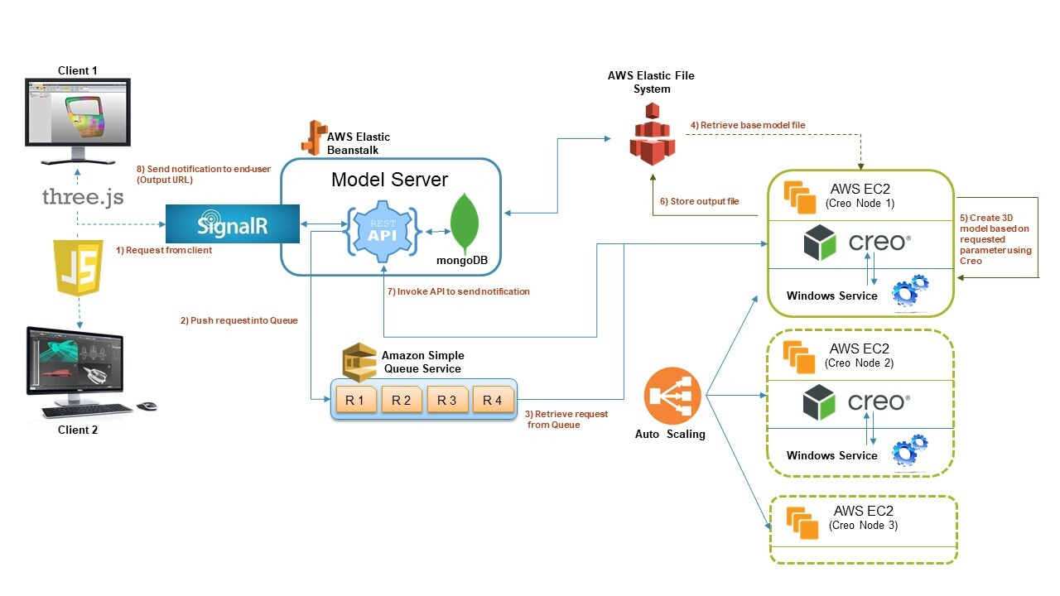
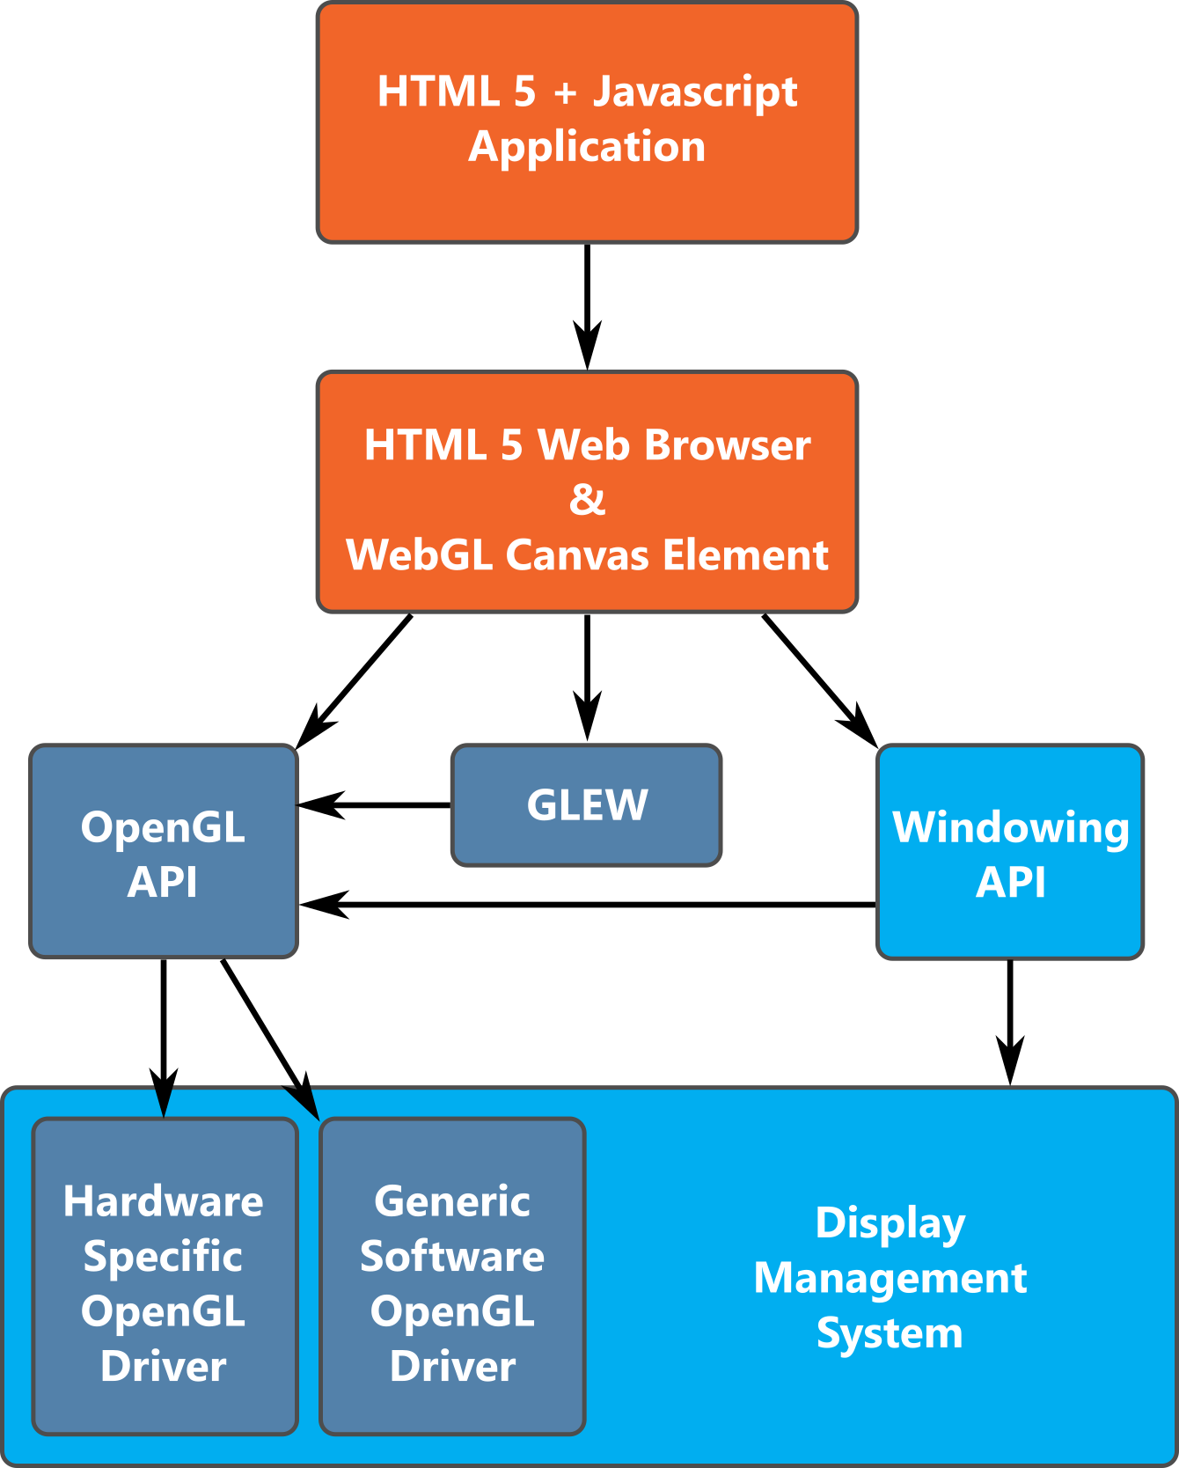
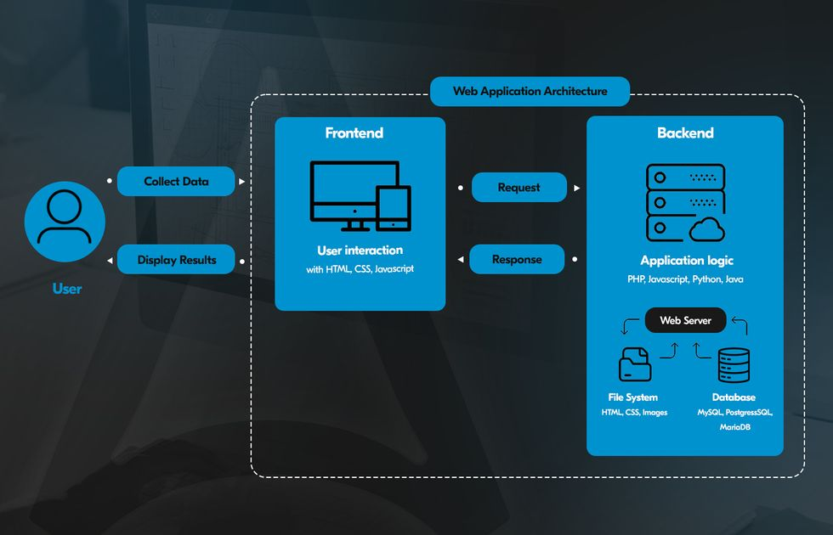

7.2 Figure 2: CMS Content Model / ERD
Here: CMS Content Types — Pages, Sections, Services, Products, Industries, Insights, Careers, Partners, Global Settings
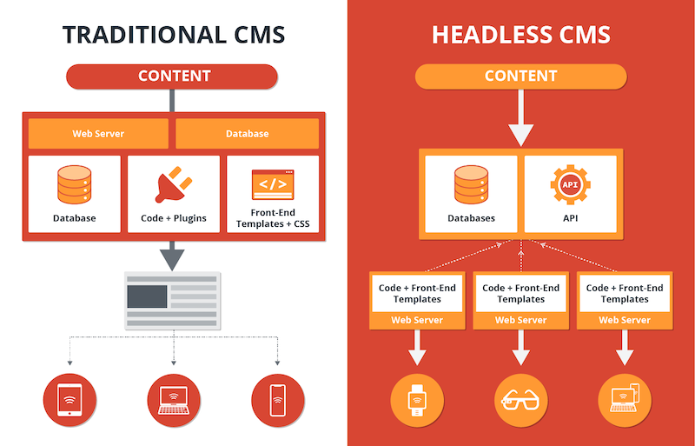

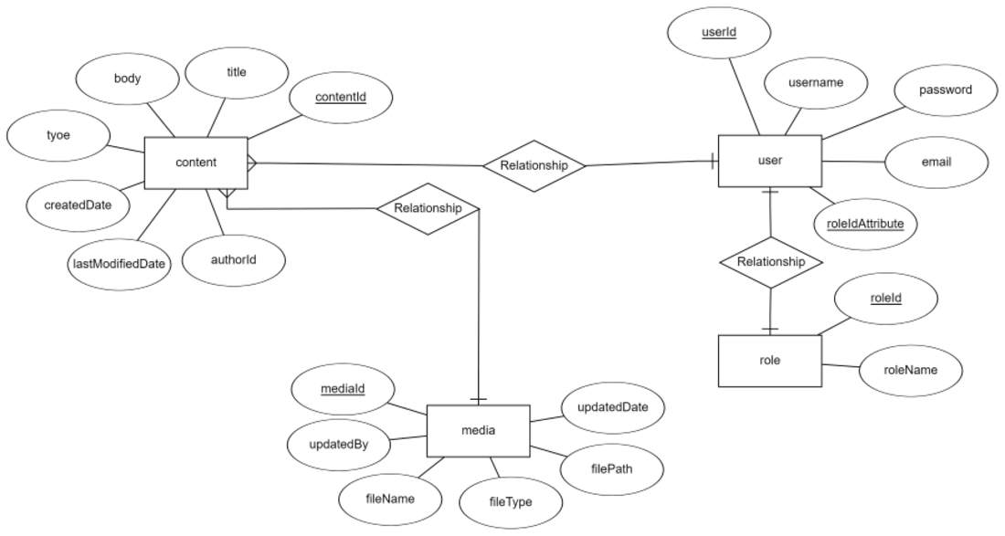

7.3 Figure 3: Deployment & CI/CD Pipeline Diagram
Git → CI (Build/Test) → Staging → QA → Prod Deploy → Monitoring/Alerts
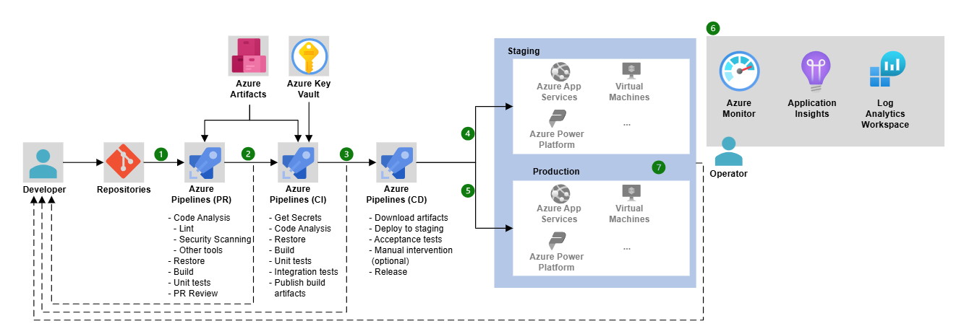
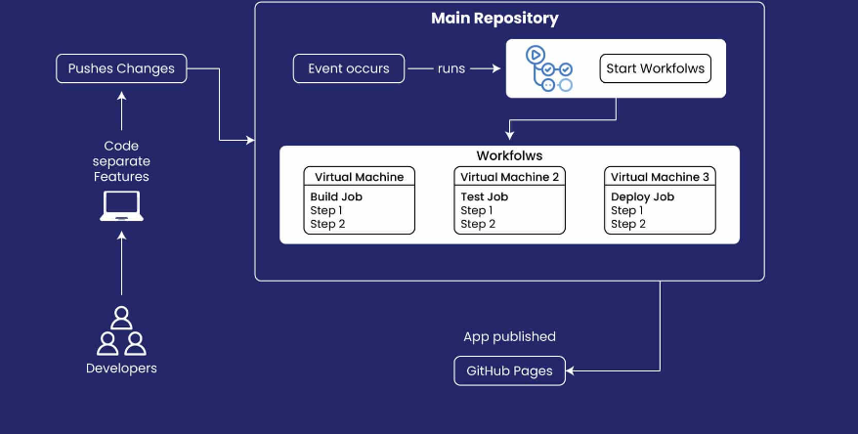

8. Security, Performance & Compliance

8.1 Security Controls
- HTTPS everywhere (TLS), HSTS, secure cookies, and strict transport policies.
- Content Security Policy (CSP), XSS/Clickjacking protections, CORS hardening.
- Bot protection for public endpoints (forms, APIs).
- Secrets management and least privilege access for deployments.
- Dependency vulnerability scanning and regular patching.

8.2 Performance & Accessibility
- Asset optimization: compression, CDN caching, code splitting, lazy loading.
- 3D performance: device-tier quality presets, LOD, instancing, texture compression.
- Core Web Vitals monitoring and regression gating in CI.
- Accessibility: reduced-motion option, keyboard navigation, semantic HTML for non-3D content.

9. Development Methodology
- Agile delivery in 2-week sprints with backlog grooming, sprint planning, demo, and retrospective.
- Definition of Done includes code review, unit/integration checks (where applicable), QA pass, and deployment to staging.
- Weekly progress reporting and transparent risk/change management.

10. Deliverables
- Production-ready website source code (frontend) + CMS configuration/export (as applicable).
- Reusable 3D scene framework and documented asset pipeline requirements.
- API/CMS documentation, content model document, and environment setup guide.
- CI/CD pipeline configuration and deployment runbook.
- Test plan + QA reports.
- Handover workshop and post-launch warranty support (as agreed).
- 3 months of complimentary support after delivery (minor bug fixes, basic monitoring guidance, and performance-related frontend issues).
Complimentary Support (3 Months)
- - Bug fixing for minor UI issues and crashes reproducible in supported environments.
- - Basic performance tuning and UI responsiveness improvements.
- - Assistance interpreting frontend logs and issues (requires Client to provide access to crash/analytics tools).
- Note: Feature enhancements, new screens, or changes due to backend/API changes are excluded and treated as change requests.

11. Relevant Project References
The following references demonstrate experience with modern websites, interactive experiences, and content-driven portals:
- HitSqwad – https://hitsqwad.com/
- Arc iGaming – https://arcigaming.com/
- Spark Infrastructure Ltd – https://silbd.net/
- Shanti Jewels eCommerce Website – https://shaantijewels.com/
- Sisimpur – https://riseuplabs.com/sisimpur/

Financial Proposal
The financial estimate below is structured per phase. Exact cost depends on final scope, number of unique 3D scenes/assets, CMS choice, integrations, and localization depth.

A. Phase-wise Effort & Cost
Phase | Scope Focus | Weeks | Estimated Cost (USD) | Parallel Development
Phase 1 | Foundation, CMS, Core Website Skeleton | 3 | $4,500 | Timeline: 10 Weeks
Phase 2 | Immersive 3D Experiences & Deep Page Buildout | 8 | $12,000 | Timeline: 10 Weeks
Phase 3 | Hardening, Localization (EN/AR), Deployment & Handover | 3 | $3,500 | Timeline: 10 Weeks

B. Payment Terms
- Each phase will commence after confirming the phase scope and receiving 30% advance payment for that phase.
- The remaining 70% payment for that phase will be due upon completion and handover of deliverables for that phase.
- The next phase will start only after the previous phase payment has been cleared.
- Any scope changes or additional requests will be handled through a mutually agreed change request (CR) process.

C. Remarks
- The above is a development-only estimation; UI/UX design, creative direction, and content production are excluded.
- 3D asset production (modeling, texturing, animation) is not included unless it is explicitly added as a separate line item.
- Third-party tools (CMS subscriptions, analytics, search, CDN, etc.) are billed directly to the client unless otherwise agreed.

Conclusion
This proposal outlines a phased, development-only approach to deliver a high-quality immersive SWARM website built from scratch using Three.js and modern web architecture. The phased plan ensures early validation of foundations, followed by immersive experience implementation, then production hardening and launch readiness.

